Project 2 (BOIDS) GDD

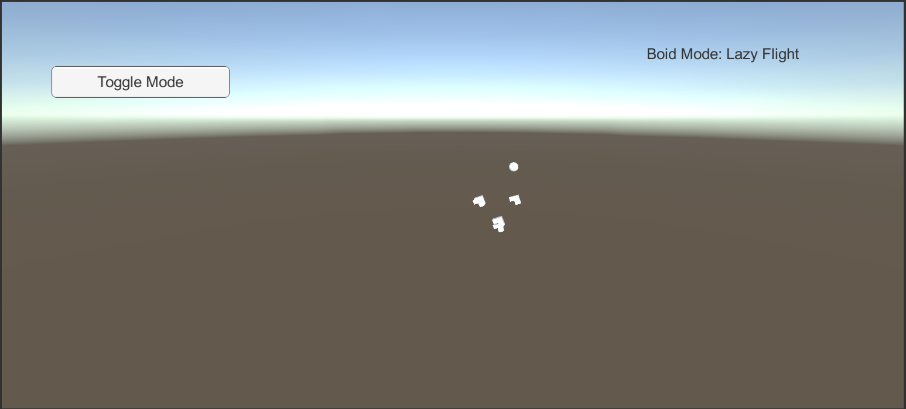

***‘I mean, I guess they sort of work’*** – Blake Myers

This page: Table of Contents and Team Member Listing

|  |  |  |
| --- | --- | --- |
| Table of Contents  [1 Game Overview](https://n-xovwktmtjsnaxyc2mwes2xu7pohqedmdm6zjw5q-2lu-script.googleusercontent.com/userCodeAppPanel)  [2 High Concept](https://n-xovwktmtjsnaxyc2mwes2xu7pohqedmdm6zjw5q-2lu-script.googleusercontent.com/userCodeAppPanel)  [3 Unique Selling Points](https://n-xovwktmtjsnaxyc2mwes2xu7pohqedmdm6zjw5q-2lu-script.googleusercontent.com/userCodeAppPanel)  [4 Platform Minimum Requirements](https://n-xovwktmtjsnaxyc2mwes2xu7pohqedmdm6zjw5q-2lu-script.googleusercontent.com/userCodeAppPanel)  [5 Competitors / Similar Titles](https://n-xovwktmtjsnaxyc2mwes2xu7pohqedmdm6zjw5q-2lu-script.googleusercontent.com/userCodeAppPanel)  [6 Synopsis](https://n-xovwktmtjsnaxyc2mwes2xu7pohqedmdm6zjw5q-2lu-script.googleusercontent.com/userCodeAppPanel)  [7 Game Objectives](https://n-xovwktmtjsnaxyc2mwes2xu7pohqedmdm6zjw5q-2lu-script.googleusercontent.com/userCodeAppPanel)  [8 Game Rules](https://n-xovwktmtjsnaxyc2mwes2xu7pohqedmdm6zjw5q-2lu-script.googleusercontent.com/userCodeAppPanel)  [9 Game Structure](https://n-xovwktmtjsnaxyc2mwes2xu7pohqedmdm6zjw5q-2lu-script.googleusercontent.com/userCodeAppPanel)  [10 Game Play](https://n-xovwktmtjsnaxyc2mwes2xu7pohqedmdm6zjw5q-2lu-script.googleusercontent.com/userCodeAppPanel)  [10.1 Game Controls](https://n-xovwktmtjsnaxyc2mwes2xu7pohqedmdm6zjw5q-2lu-script.googleusercontent.com/userCodeAppPanel)  [10.2 Game Camera](https://n-xovwktmtjsnaxyc2mwes2xu7pohqedmdm6zjw5q-2lu-script.googleusercontent.com/userCodeAppPanel)  [10.2.1 HUD](https://n-xovwktmtjsnaxyc2mwes2xu7pohqedmdm6zjw5q-2lu-script.googleusercontent.com/userCodeAppPanel)  [11 Players](https://n-xovwktmtjsnaxyc2mwes2xu7pohqedmdm6zjw5q-2lu-script.googleusercontent.com/userCodeAppPanel)  [12 NPC](https://n-xovwktmtjsnaxyc2mwes2xu7pohqedmdm6zjw5q-2lu-script.googleusercontent.com/userCodeAppPanel)  12.1 Boids  [13 Art](https://n-xovwktmtjsnaxyc2mwes2xu7pohqedmdm6zjw5q-2lu-script.googleusercontent.com/userCodeAppPanel)  [13.1 Setting](https://n-xovwktmtjsnaxyc2mwes2xu7pohqedmdm6zjw5q-2lu-script.googleusercontent.com/userCodeAppPanel)  [13.2 Level Design](https://n-xovwktmtjsnaxyc2mwes2xu7pohqedmdm6zjw5q-2lu-script.googleusercontent.com/userCodeAppPanel)  [14 Procedurally Generated Content](https://n-xovwktmtjsnaxyc2mwes2xu7pohqedmdm6zjw5q-2lu-script.googleusercontent.com/userCodeAppPanel)  [14.1 Levels](https://n-xovwktmtjsnaxyc2mwes2xu7pohqedmdm6zjw5q-2lu-script.googleusercontent.com/userCodeAppPanel)  [14.2 Artificial Intelligence NPC](https://n-xovwktmtjsnaxyc2mwes2xu7pohqedmdm6zjw5q-2lu-script.googleusercontent.com/userCodeAppPanel)  [14.3 Minimum Viable Product (MPV)](https://n-xovwktmtjsnaxyc2mwes2xu7pohqedmdm6zjw5q-2lu-script.googleusercontent.com/userCodeAppPanel)  [15 Wish List](https://n-xovwktmtjsnaxyc2mwes2xu7pohqedmdm6zjw5q-2lu-script.googleusercontent.com/userCodeAppPanel)   |  | | --- | |  | | Game Development Team Members    PRODUCER  Blake Myers    PRODUCTION MANAGER  Blake Myers    PRODUCTION COORDINATOR  Blake Myers  GAME DESIGNERS  Blake Myers  SYSTEMS/IT COORDINATOR  Blake Myers  PROGRAMMERS  Blake Myers  TECHNICAL ARTISTS  Blake Myers  AUDIO ENGINEERS  Blake Myers  UX TESTERS  Blake Myers |

|  |
| --- |
|  |

# 1 Game Overview

Title: CS 596 Project 2

Platform: PC Standalone

Genre: Tech Demo

Rating: E (ESRB pending)

Target: Professor Price

Release date: April 11, 2020

Publisher: Blake Myers

Description: A demo Scene where triangular arrow shape entities display one of two types of flocking behavior at a time.

# 2 High Concept

A Demo where Boids display various forms of flocking behavior.

# 3 Unique Selling Points

There are no Unique selling points of this Demo.

# 4 Platform Minimum Requirements

Windows 10, intel i5 3Ghz, Nvidia Gtx 960ti, 8GB Ram

# 5 Competitors / Similar Titles

Any Project 2 from other students in CS 596

# 6 Synopsis

Triangular shaped AI (Boids) fly toward a sphere indicating a goal while in Lazy Flight mode. Alternatively Circle a Tree mode can be used to have the Boids fly around a sphere (tree) in the center of the scene.

# 7 Game Objectives

There are no objectives, this is a tech demo.

# 8 Game Rules

There are no rules because this is not a game.

# 9 Game Structure

There is only one level with no intro menu, if played from a build the structure is:

Splash Screen 🡪 Boid Demo Screen

# 10 Game Play

## 10.1 Game Controls

The only thing the player can interact with is the **Toggle Mode** button in the HUD. It is activated with a left click

## 10.2 Game Camera

The Camera is spaced and angled to sufficiently show the Boids in action.

### 10.2.1 HUD

There are two Hud Elements, the first is a button labeled **Toggle Mode**, Which Switches the Boids from lazy flight mode to circle a tree mode. The second HUD element is a text line which states the current mode of the Boids.

# 11 Players

There are no playable characters in this game

# 12 NPC

## 12.1 Boids

You cannot play as the Boids in the Demo and they traverse the scene according to the Flight mode they are in.

# 13 Art

## 13.1 Setting

The Demo takes place in a blue and gray abyss.

## 13.2 Level Design

## 13.3 Audio

There is no Audio in this demo

# 14 Procedurally Generated Content

## 14.1 Environment

Boids traverse a 20 x 20 x 20 world unit area towards its designated goal depending on its flight mode. The Goals are created randomly in this area and change every time the demo is ran.

## 14.2 Levels

There is only one level.

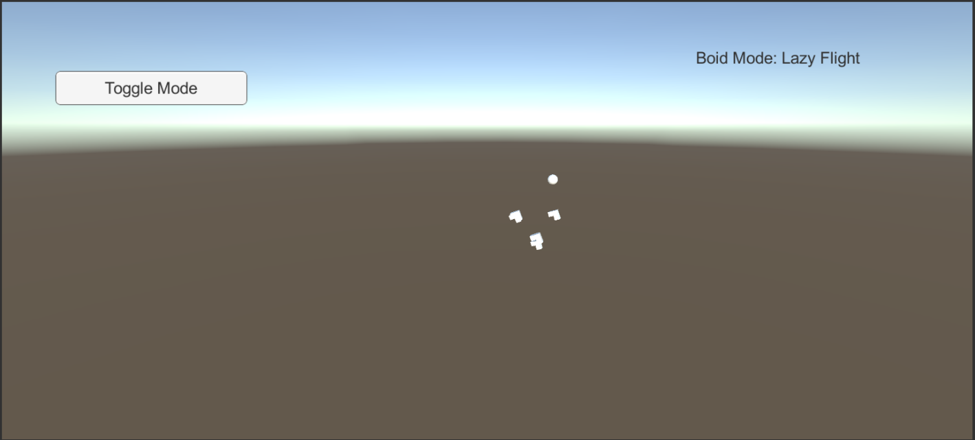

## 14.3 Artificial Intelligence NPC

The Boids Group up in flocks with nearby Boids, while in a flock they attempt to avoid each other while all traveling in the same general direction.

## 14.4 Minimum Viable Product (MPV)

A working demo displaying two types of Boid flight behavior.

# 15 Wish List

It would have been cool if I made the Boids spaceships, so it looks like they were dogfighting.

Works Cited

Tutorial Used to Create Basic Flocking behavior:

Holistic3d, director. *Flocking Fish in Unity 5: Creating Schooling Behaviour with Simple AI*. *YouTube*, 10 Mar. 2016, www.youtube.com/watch?v=eMpI1eCsIyM.